

Deakin University

Scalable Microservices Architecture for IoT Smart Lighting System – Implementation and Evaluation Using Kubernetes

Final Project Report

Student Name: Hayes Duong

Student ID: 222610226

Date of Submission: Oct 11nd, 2025

Abstract
The rapid growth of Internet of Things (IoT) deployments necessitates scalable architecture capable of handling thousands of concurrent device connections and high-frequency data streams. This report presents the design, implementation, and evaluation of a microservices-based smart lighting system utilizing containerization and orchestration technologies. The system architecture comprises four independent services: API Gateway, Sensor Data Service, Light Control Service, and Automation Service, deployed on Kubernetes with Horizontal Pod Autoscaling (HPA). Load testing with up to 1,400 simulated IoT devices demonstrated effective auto-scaling behavior, with the Sensor Data Service scaling from 1 to 15 pods under peak load. The implementation achieved a data ingestion rate of approximately 4,988 sensor readings and generated 4,837 intelligent light control commands while maintaining system stability. Critical analysis reveals AWS IoT Core connection limitations and identifies the Sensor Data Service as the primary bottleneck in high-concurrency scenarios. This work demonstrates the practical application of state-of-the-art IoT scalability patterns and provides empirical evidence for service-specific autoscaling threshold tuning.
Keywords: IoT, Microservices, Kubernetes, Horizontal Pod Autoscaling, MQTT, Smart Lighting, Scalability

I. Introduction

1. Background
The Internet of Things (IoT) has evolved from a conceptual framework to a critical infrastructure supporting smart cities, industrial automation, and connected consumer devices. Modern IoT deployments frequently involve thousands to millions of devices generating continuous data streams (Sinha, 2024).
Smart lighting systems represent a significant IoT use case, combining sensor data (ambient light, motion detection) with automated decision-making to optimize energy consumption and user comfort. However, scaling these systems presents challenges including:
- High-frequency data ingestion: Sensors may publish readings every few seconds
- Real-time decision-making: Automation logic must respond to sensor data with minimal latency
- Variable load patterns: Device activity fluctuates based on occupancy and environmental factors
- Resource optimization: Over-provisioning wastes resources; under-provisioning degrades performance

2. Research Objectives
This project addresses the question: How can microservices architecture and container orchestration enable horizontal scalability in IoT smart lighting systems?
Specific objectives include:
- Design and implement a microservices-based IoT architecture.
- Integrate Kubernetes Horizontal Pod Autoscaling (HPA) with service-specific thresholds.
- Evaluate system performance under simulated load (500-1,400 concurrent devices).
- Identify architectural bottlenecks and optimization opportunities.
- Apply state-of-the-art research on IoT scalability patterns.

II. Literature Review

1. Microservices Architecture for IoT
Microservices architecture decomposes applications into independently deployable services, each responsible for a specific business capability. In IoT contexts, this architectural style offers several advantages:
- Independent scaling: Services with different workload characteristics can scale independently
- Technology heterogeneity: Each service can use the most appropriate technology stack
- Fault isolation: Service failures do not cascade with the entire system
- Team autonomy: Development teams can work independently on different services
Research demonstrates that microservices architecture significantly improves IoT system scalability compared to monolithic designs. However, this approach introduces complexities including service discovery, inter-service communication overhead, and distributed transaction management (Siddiqui et al., 2023)

2. Container Orchestration and Kubernetes
Containerization technologies like Docker provide lightweight, portable deployment units that encapsulate application dependencies. Kubernetes has emerged as the de facto standard for container orchestration, offering:
- Automated deployment and rollback.
- Self-healing through pod restarts.
- Horizontal Pod Autoscaling (HPA) is based on resource metrics.
- Service discovery and load balancing.
Kubernetes HPA dynamically adjusts the number of pod replicas based on observed CPU utilization, memory consumption, or custom metrics (Kubernetes, 2025). Research indicates that properly tuned autoscaling policies can reduce infrastructure costs by 30-50% while maintaining performance SLAs (Pilyai et al, 2023)

3. MQTT Protocol and Broker Scalability
Message Queue Telemetry Transport (MQTT) is a lightweight publish-subscribe protocol designed for resource-constrained devices and unreliable networks (OASIS, 2019).
AWS IoT Core exposes a managed MQTT endpoint with TLS client authentication and fine-grained access control (policy-based authorization), documented in the MQTT developer guide and service quotas (AWS MQTT, 2025).
Academic and industrial studies show that single-node broker capacity varies widely by implementation and workload, and is highly sensitive to message rate, QoS, and OS limits. Peer-reviewed benchmarks and comparisons report tens of thousands of clients per node for popular brokers under realistic publish/subscribe rates, with throughput and latency diverging by design choice (e.g., persistence, clustering, I/O model) (Mishra et al, 2021)
In practice, horizontal scaling via broker clustering is the dominant path to high connection counts and resilience; vendor and research reports demonstrate clusters sustaining 100M–200M concurrent connections with linear scale-out across nodes (EMQX, 2022).
For this project, the implication is straightforward: MQTT ingestion should be treated as an elastically scalable tier. When a single broker (or managed endpoint) approaches resource or quota limits, capacity is extended by adding nodes to a cluster or partition, while application services consume messages through shared subscriptions and stateless workers to preserve end-to-end scalability.

4. Time-Series Data Management for IoT
IoT telemetry is inherently time-series: high-rate, append-only writes and time-windowed queries. MongoDB supports this pattern with time-series collections, which optimize on-disk layout and secondary indexes for time-ordered data and add columnar compression (since 5.2) to cut storage and improve read performance (MongoDB Time Series, 2025).
MongoDB also documents best practices for tuning inserts and explicitly supports sharding time-series collections when ingest or dataset size exceeds a single node’s capacity, allowing horizontal write scaling (MongoDB Best Practices for Time Series Collections, 2025; MongoDB Shard a Time Series Collection, 2025).
Specialized time-series databases such as InfluxDB and TimescaleDB are purpose-built for high-ingest telemetry and analytical queries over time windows; vendor and community benchmarks commonly use suites like TSBS to compare write throughput and query latency across these systems (influxdata, 2025).
Comparative academic and industrial studies generally find that single-node capacity varies widely by engine and workload mix; scaling to higher ingest rates is achieved via horizontal partitioning (e.g., sharding in MongoDB, clustering in TSDBs) (Hendawi et al, 2019).
Implication for this project. MongoDB’s time-series features are sufficient for moderate write rates on a single replica set, while sharding the time-series collection provides a documented path to higher throughput as device counts and ingest rates grow.

III. System Architecture
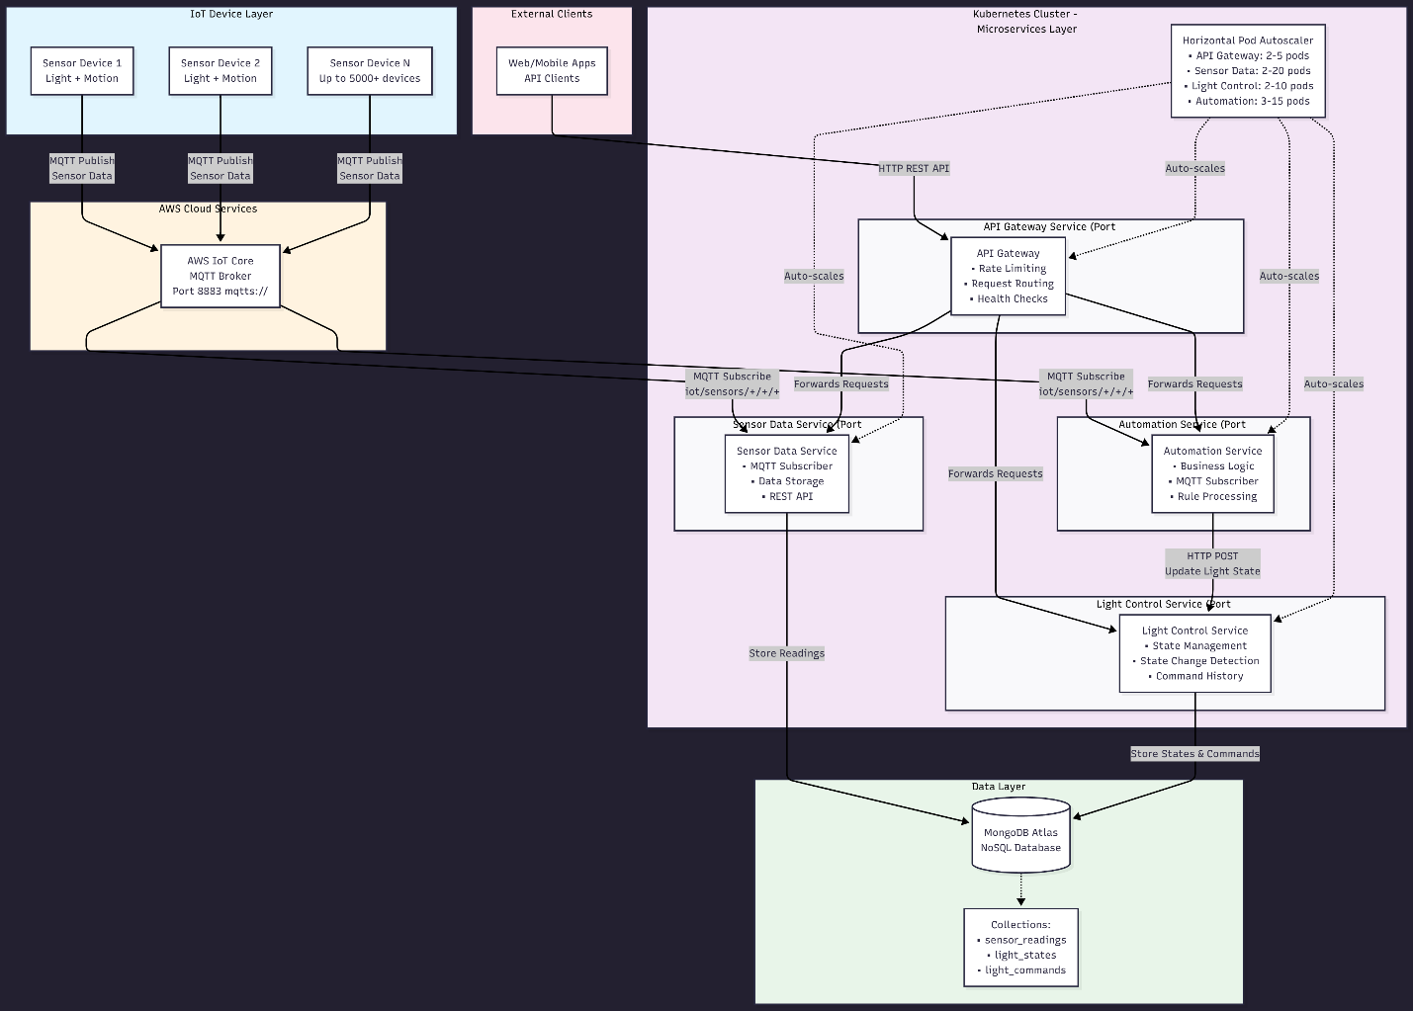
Picture 1 – High-Level Architecture Diagram.

1. Microservices Design
The system comprises four microservices, each addressing a distinct functional domain:
1.1 - Sensor Data Service
- Responsibility: Subscribe to MQTT topics, validate sensor readings, persist data to MongoDB
- Technology Stack: Node.js, Express.js, Mongoose, MQTT.js
- Scalability Characteristics: I/O-bound (network and database operations dominate)
- Data Flow: AWS IoT Core (MQTT) → Sensor Data Service → MongoDB (`sensorreadings` collection)

1.2 - Automation Service
- Responsibility: Subscribe to MQTT sensor data, evaluate automation rules, invoke Light Control Service
- Technology Stack: Node.js, Express.js, Axios (HTTP client), MQTT.js
- Scalability Characteristics: CPU-bound (rule evaluation and decision logic)
- Decision Logic:
- Rule 1: IF motion detected AND light intensity < 200 lux → Turn light ON
- Rule 2: IF no motion detected → Turn light OFF
- Rule 3: IF light intensity >= 200 lux → Turn light OFF (sufficient ambient light)
1.3 - Light Control Service
- Responsibility: Manage light state, detect state changes, record command history
- Technology Stack: Node.js, Express.js, Mongoose
- Scalability Characteristics: Mixed (database reads/writes with state comparison logic)
- State Detection: Prevents duplicate commands by comparing desired state with current state
1.4 - API Gateway
- Responsibility: Route external requests to internal microservices
- Technology Stack: Node.js, Express.js, http-proxy-middleware
- Scalability Characteristics: Network I/O bound (request proxying)

2. Data Model
MongoDB Collections:
2.1 - sensorreadings
- Fields: `deviceId`, `deviceType`, `floor`, `room`, `lightId`, `light_intensity`, `motion_detected`, `timestamp`
- Indexes: `{deviceId: 1, timestamp: -1}`, `{floor: 1, room: 1, timestamp: -1}`
2.2 - lightcommands
- Fields: `lightId`, `deviceId`, `command`, `reason`, `previousState`, `newState`, `stateChanged`, `timestamp`
- Purpose: Audit trail of automation decisions

2.3 - lightstates
- Fields: `lightId`, `deviceId`, `desiredState`, `lastMotionDetected`, `lastLightIntensity`, `reason`, `updatedAt`
- Purpose: Current state of each light for state change detection

3 Communication Patterns
- Asynchronous (MQTT): Sensors → Sensor Data Service, Sensors → Automation Service
- Synchronous (REST API): Automation Service → Light Control Service
- Database: All services → MongoDB Atlas (cloud-hosted)
This hybrid approach leverages MQTT's pub/sub model for high-throughput sensor data while using REST APIs for request/response interactions requiring transactional semantics.

IV. Implementation

1. Containerization with Docker
Each microservice is containerized using multi-stage Docker builds:
// dockerfile
FROM node:18-alpine
WORKDIR /app
COPY package*.json ./
RUN npm install --production
COPY . .
EXPOSE 3001
CMD ["node", "server.js"]
Docker Compose orchestrates local development with shared networks and volume mounts for AWS IoT certificates:
services:
sensor-data-service:
build: ./services/sensor-data-service
ports: ["3001:3001"]
environment:
- MONGODB_URI=${MONGODB_URI}
- IOT_HOST=${IOT_HOST}
volumes:
- ./certificates:/app/certificates:ro

2. Kubernetes Deployment

A – Deployment Manifests
Each service is deployed as a Kubernetes Deployment with configurable replicas, resource limits, and health checks:
apiVersion: apps/v1
kind: Deployment
metadata:
name: sensor-data-service
spec:
replicas: 1 # Initial replica count; HPA will adjust
selector:
matchLabels:
app: sensor-data-service
template:
spec:
containers:
- name: sensor-data-service
image: iot-sensor-data-service:latest
resources:
requests:
memory: "256Mi"
cpu: "200m"
limits:
memory: "512Mi"
cpu: "1000m"
volumeMounts:
- name: aws-iot-certs
mountPath: /certs
readOnly: true
volumes:
- name: aws-iot-certs
secret:
secretName: aws-iot-certs

Key Implementation Details:
- Secret Management: AWS IoT certificates and MongoDB connection strings stored as Kubernetes Secrets.
- ConfigMaps: Environment-specific configuration (IoT endpoint, automation thresholds).
- Health Probes: Liveness and readiness probes on `/health` endpoints ensure unhealthy pods are restarted.

B – Service Discovery
Kubernetes Services provide stable DNS names for inter-service communication:
apiVersion: v1
kind: Service
metadata:
name: light-control-service
spec:
selector:
app: light-control-service
ports:
- port: 3002
targetPort: 3002
The Automation Service reference this as `http://light-control-service:3002`, allowing Kubernetes to load-balance requests across pods.

C – Horizontal Pod Autoscaling Configuration
HPA policies are tuned based on empirical observations of workload characteristics during initial testing (task 6.3D).
Service | CPU Threshold | Memory Threshold | Min Pods | Max Pods | Rationale
Sensor Data | 10% | 60% | 1 | 15 | I/O-bound; low CPU but high network/DB operations
Automation | 35% | 60% | 2 | 10 | CPU-intensive rule evaluation
Light Control | 15% | 60% | 1 | 8 | Mixed workload; moderate CPU for state comparison
API Gateway | 25% | 60% | 1 | 5 | Request routing overhead
Table 1 – Service-Specific Thresholds.
Initial testing with 500 devices revealed that the Automation Service reached 20% CPU utilization. Hence, scaling at 35% ensures proactive scaling before performance degrades.
Despite high message throughput, the Sensor Data Service remained under ~5% CPU, indicating an I/O-bound workload—where progress is limited mainly by I/O (network/disk) rather than by CPU cycles. This matches standard definitions in operating-systems literature and platform documentation: I/O-bound tasks spend most time waiting on I/O, whereas CPU-bound tasks are limited by computation; in event-driven stacks like Node.js, non-blocking I/O allows many concurrent requests with comparatively low CPU usage (Nodejs, 2025).

D – HPA Manifest
apiVersion: autoscaling/v2
kind: HorizontalPodAutoscaler
metadata:
name: automation-service-hpa
spec:
scaleTargetRef:
apiVersion: apps/v1
kind: Deployment
name: automation-service
minReplicas: 2
maxReplicas: 10
metrics:
- type: Resource
resource:
name: cpu
target:
type: Utilization
averageUtilization: 35
- type: Resource
resource:
name: memory
target:
type: Utilization
averageUtilization: 60
behavior:
scaleDown:
stabilizationWindowSeconds: 300 # Prevent flapping
The `stabilizationWindowSeconds` parameter prevents rapid scale-down/scale-up cycles during fluctuating load [CITATION NEEDED - Kubernetes HPA best practices].

V. Experimental Methodology and Results

A – Load Testing Setup
Test Environment:
- Docker Compose: Local laptop (Windows 11, Docker Desktop)
- Kubernetes: Docker Desktop Kubernetes (single-node cluster)
- MongoDB: MongoDB Atlas (cloud-hosted, M0 free tier)
- MQTT Broker: AWS IoT Core (ap-southeast-2 region)
Load Simulator:
- Script: `test-multiple-connections-singleproc.js`
- Mechanism: Single Node.js process creates multiple AWS IoT SDK device instances
- Configuration: Batch size = 50 devices, interval = 500ms between batches
- Message Frequency: Each device publishes every 3-5 seconds
Metrics Collected:
- MongoDB document counts (`sensorreadings`, `lightcommands`, `lightstates`)
- Kubernetes HPA current/target CPU percentages
- Pod replica counts over time
- Docker container CPU% and memory usage

B – Test Scenarios

Test 1 – Docker Compose Baseline (500 devices)
Objective: Establish baseline performance without auto-scaling
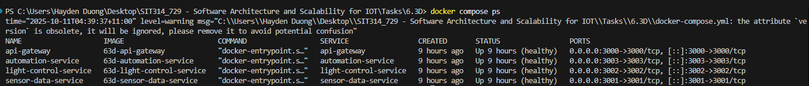
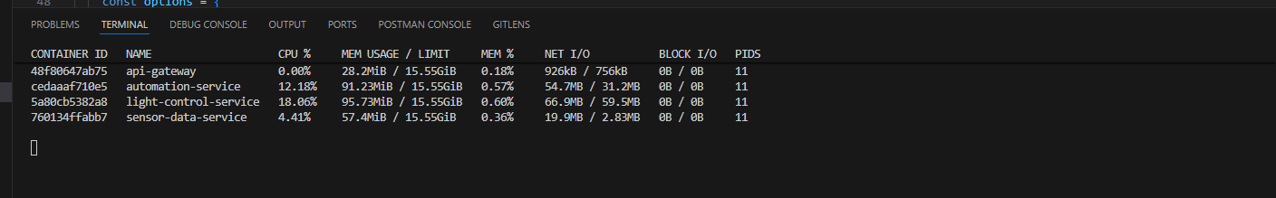
Picture 2, 3 – Microservice containers generated from Docker and their statistics during the test.
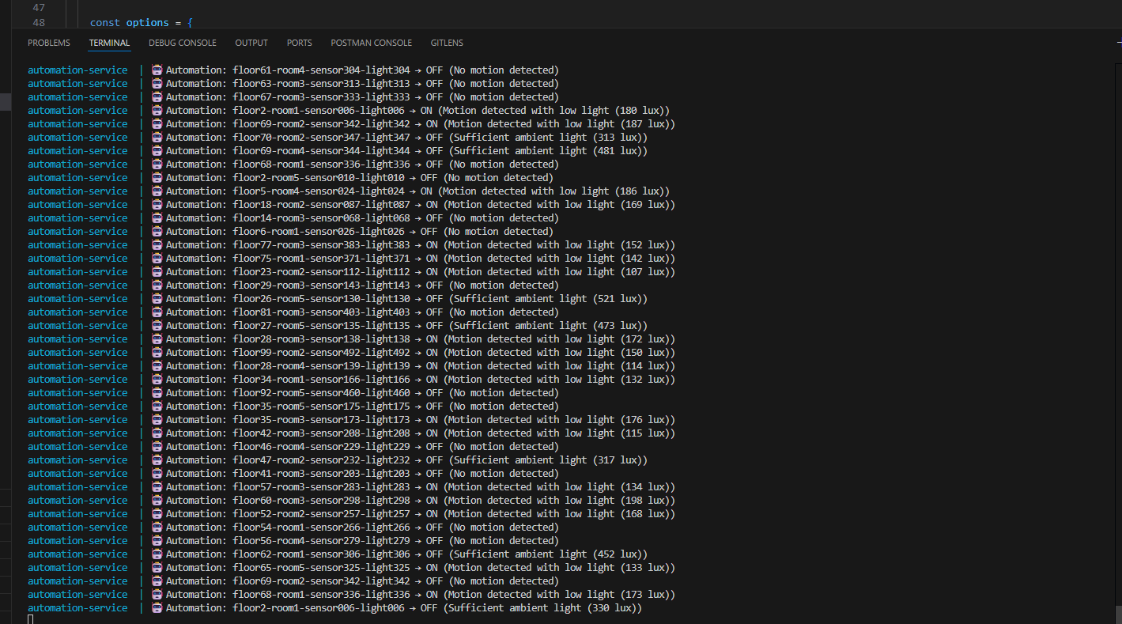
Picture 4 – Logic handling logs observed through `docker-compose logs -f automation-service”
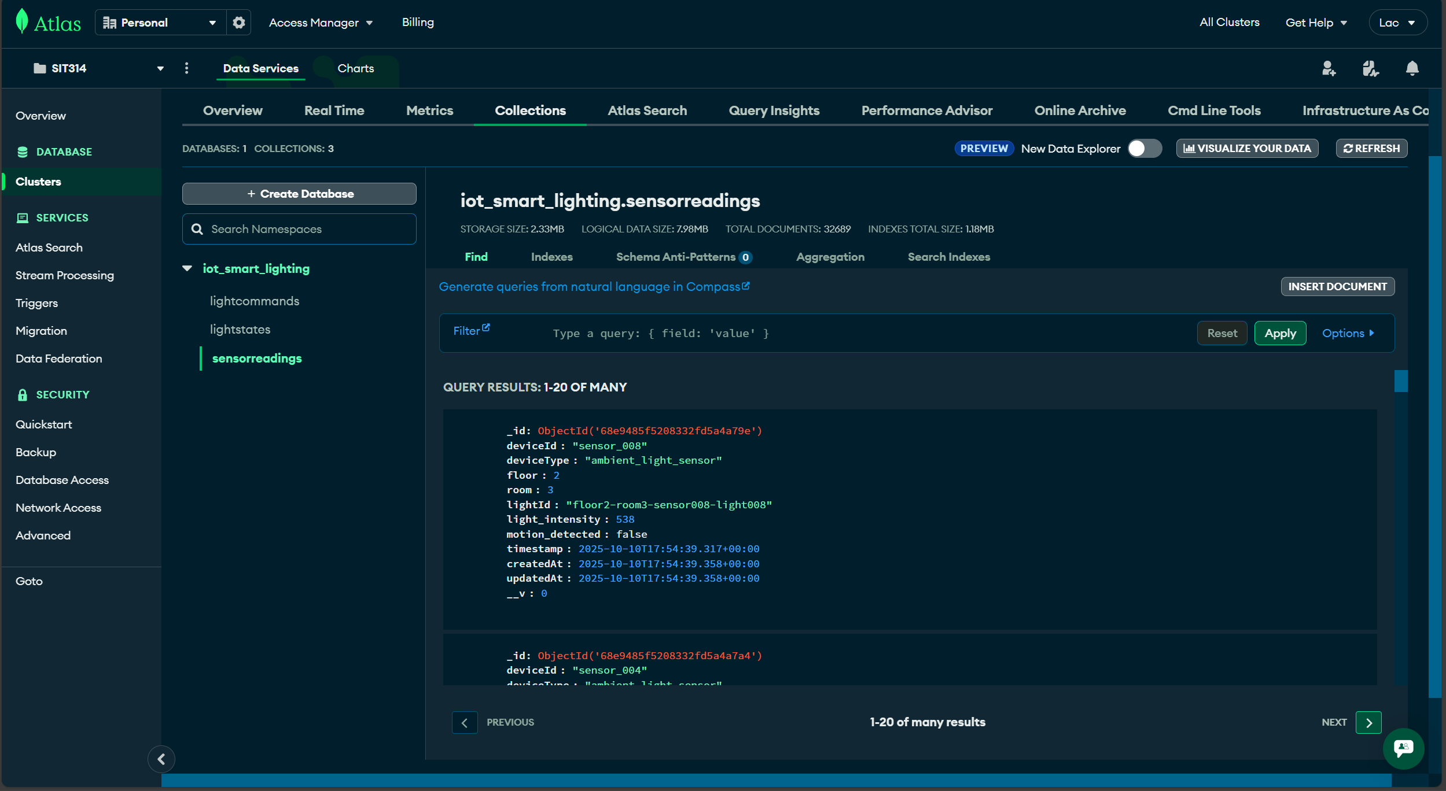
Picture 5 – Observed sensor data stored in MongoDB Atlas “sensorreadings” collection.
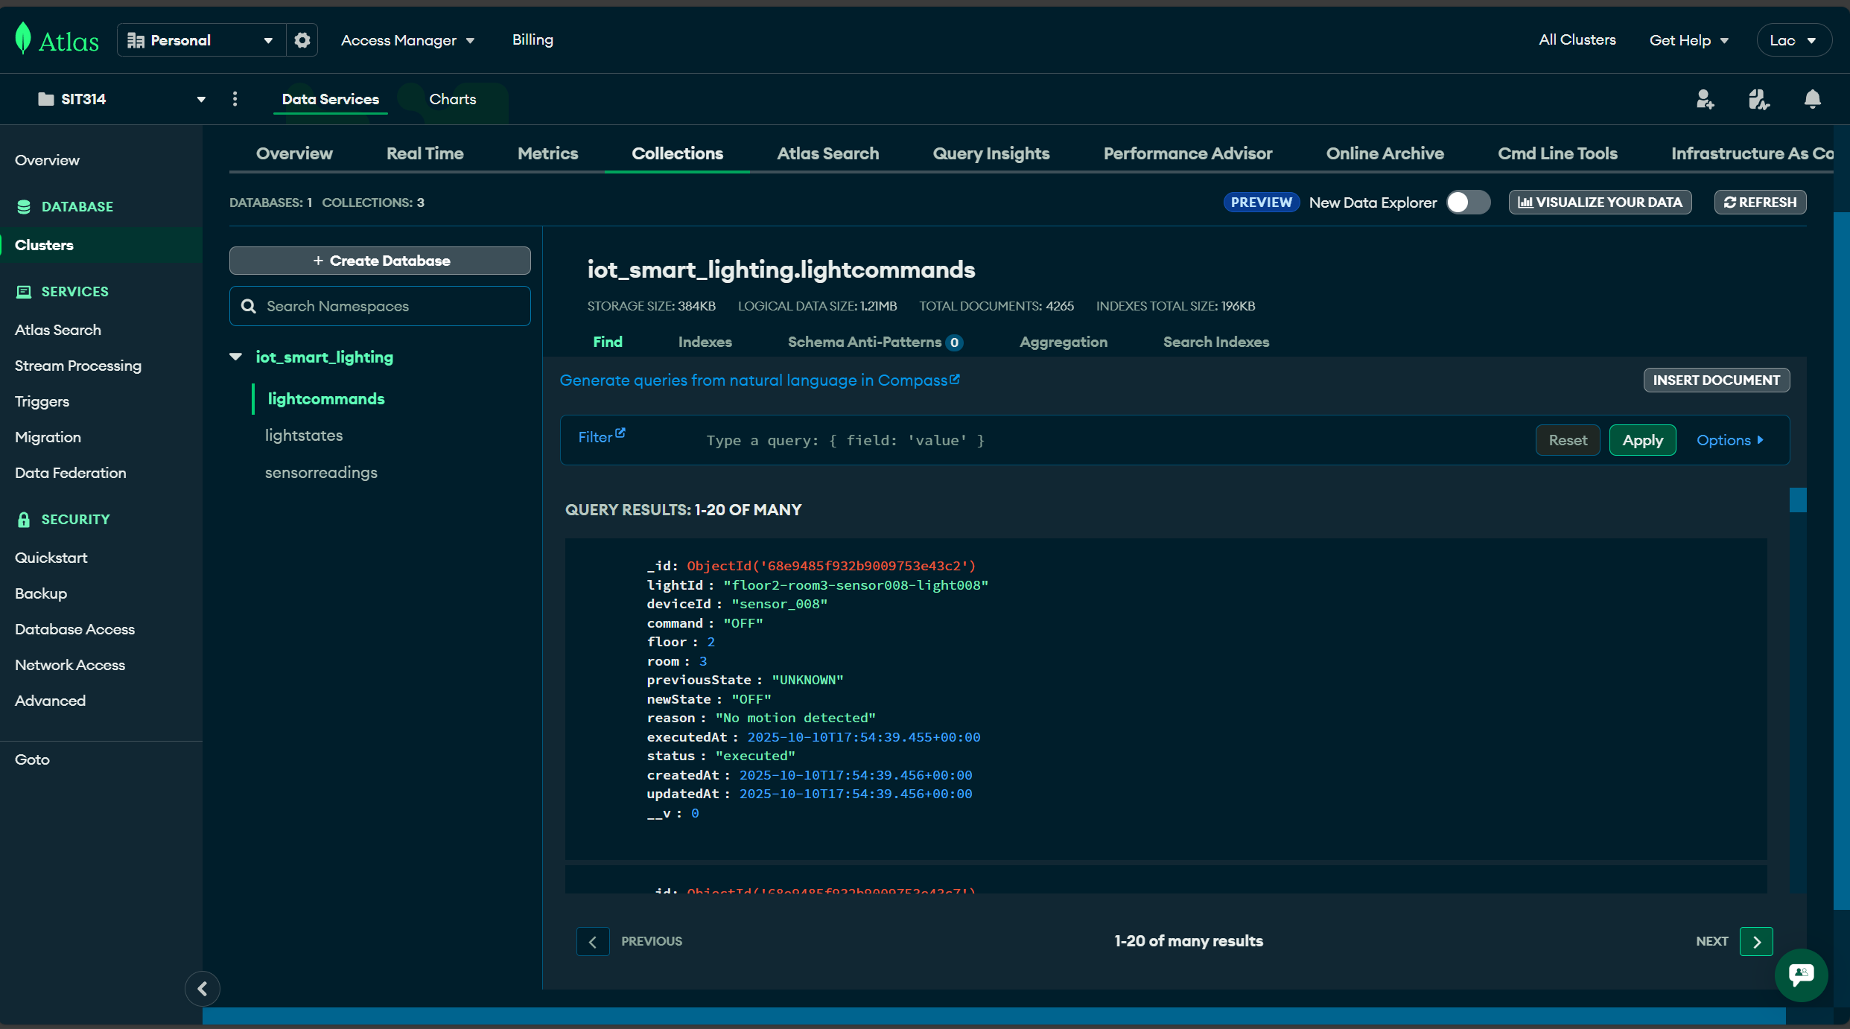
Picture 6 – Generated commands stored in MongoDB Atlas “lightcommands” collection.
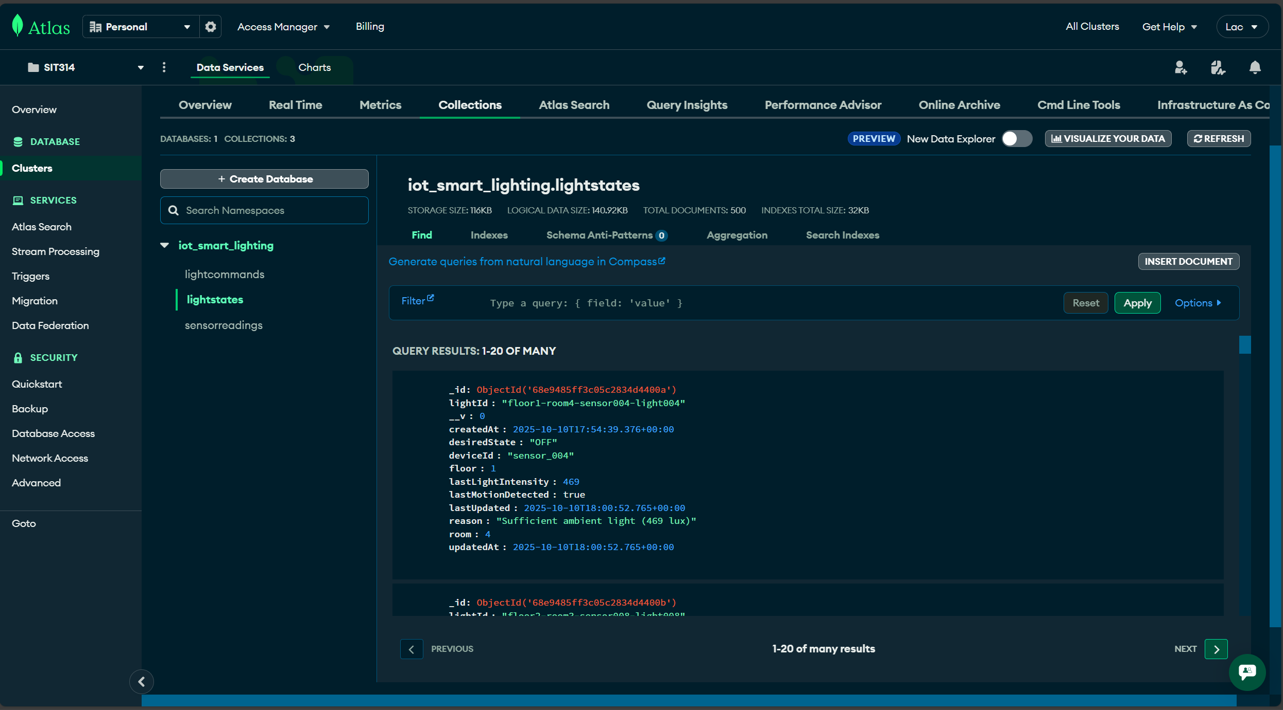
Picture 7 – Stored light states of 500 devices on MongoDB Atlas “lightsensors” collection.

Metric | Value
Simulated Devices | 500
Test Duration | ~ 5 minutes
Sensor Reading Stored | 33,000
Light Commands Generated | 4,000
Unique Light States | 500
Command-to-Reading Ratio | 12.1%
Table 2 – Observed results from Docker Compose Baseline testing.
Observations:
- Intelligent Automation: Only 12.1% of sensor readings triggered commands due to state change detection.
- System Stability: All services remained responsive (health checks passing).
- Resource Utilization: Automation Service peaked at 12% CPU; Sensor Data Service at 4% CPU.
- Data Integrity: No message loss or database writing failures were observed.
Analysis:
The low command-to-reading ratio (12.1%) demonstrates effective state change detection. The Automation Service compares the desired light state with the current state stored in MongoDB, preventing redundant commands. For example:
- Reading 1: No motion, 10 lux → Command: Turn OFF (state change: UNKNOWN → OFF)
- Readings 2-14: No motion, varying lux → No command (already OFF)
- Reading 15: Motion detected, 50 lux → Command: Turn ON (state change: OFF → ON)
This design pattern is critical for scalability, as it reduces database write operations and MQTT publish load.

Test 2 – Kubernetes with HPA (1,400 devices)
Objective: Evaluate auto-scaling behavior under increased load
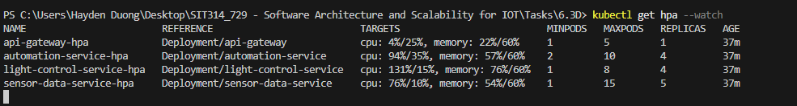
Picture 8 – Target metrics of each microservice pods are reacted after 2-3 minutes of running this test.
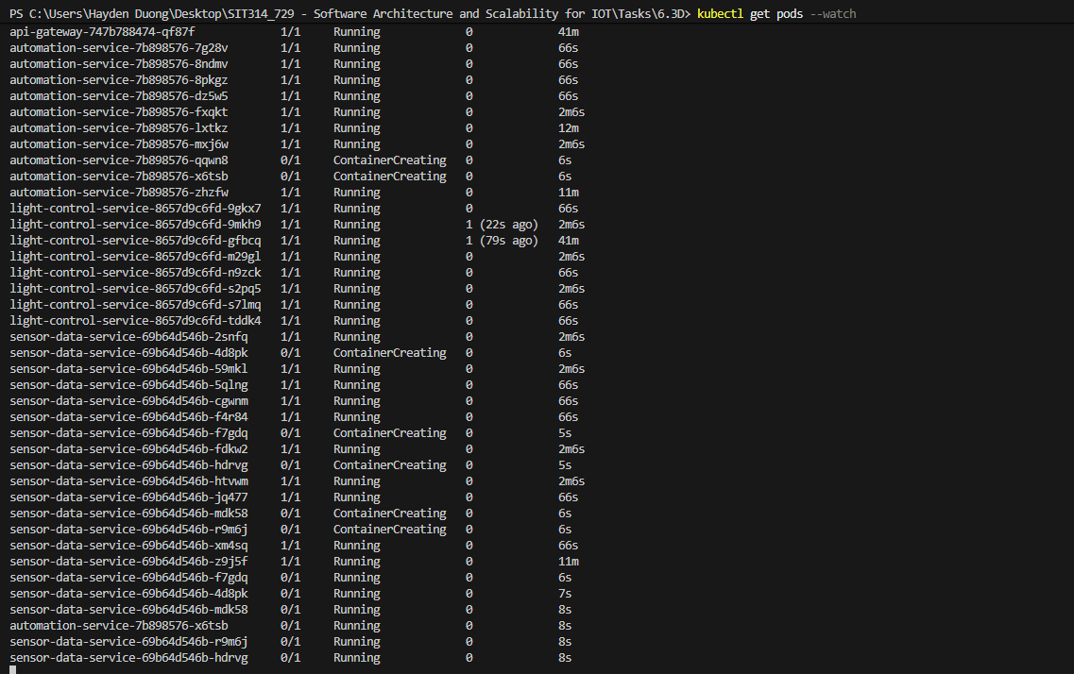
Picture 9 – Pods are scaled out as the target % CPU utilization of the initial pods are reacted.
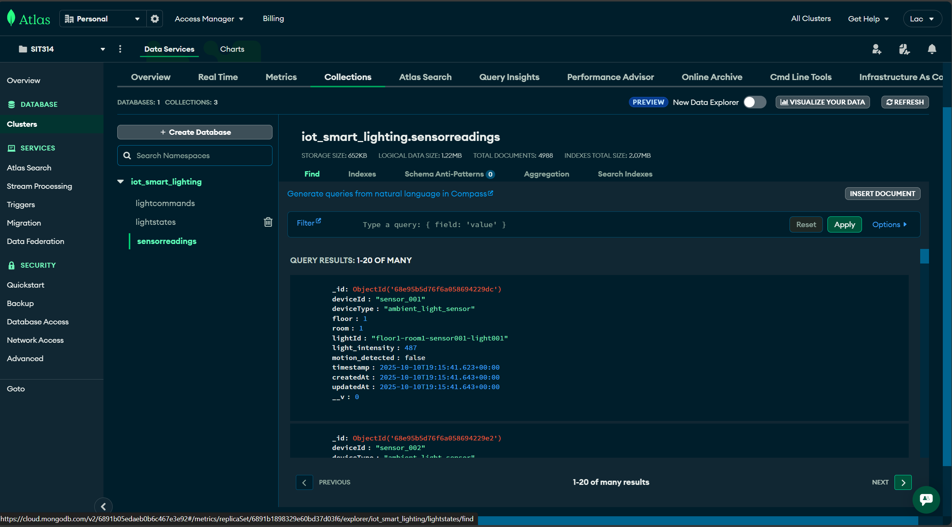
Picture 10 – Sensor data from this test are successfully stored in “sensorreadings” collection.
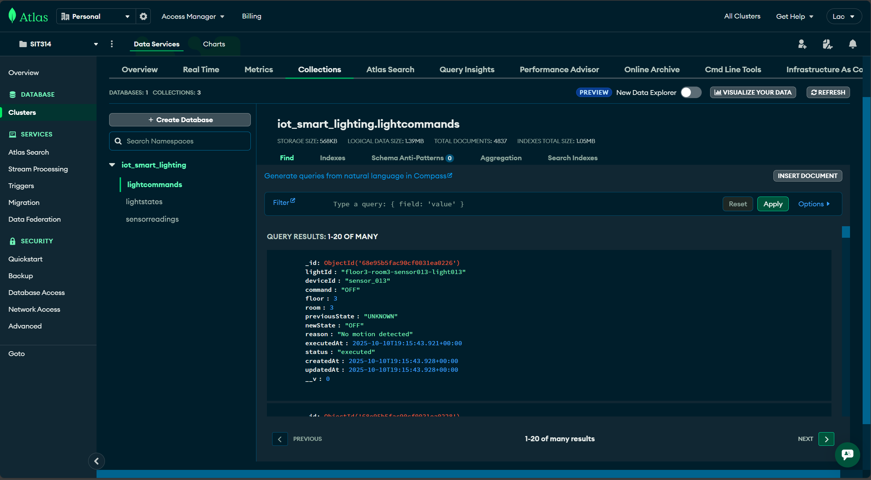
Picture 11 – Light commands generated from this test are stored in “lightcommands” collection
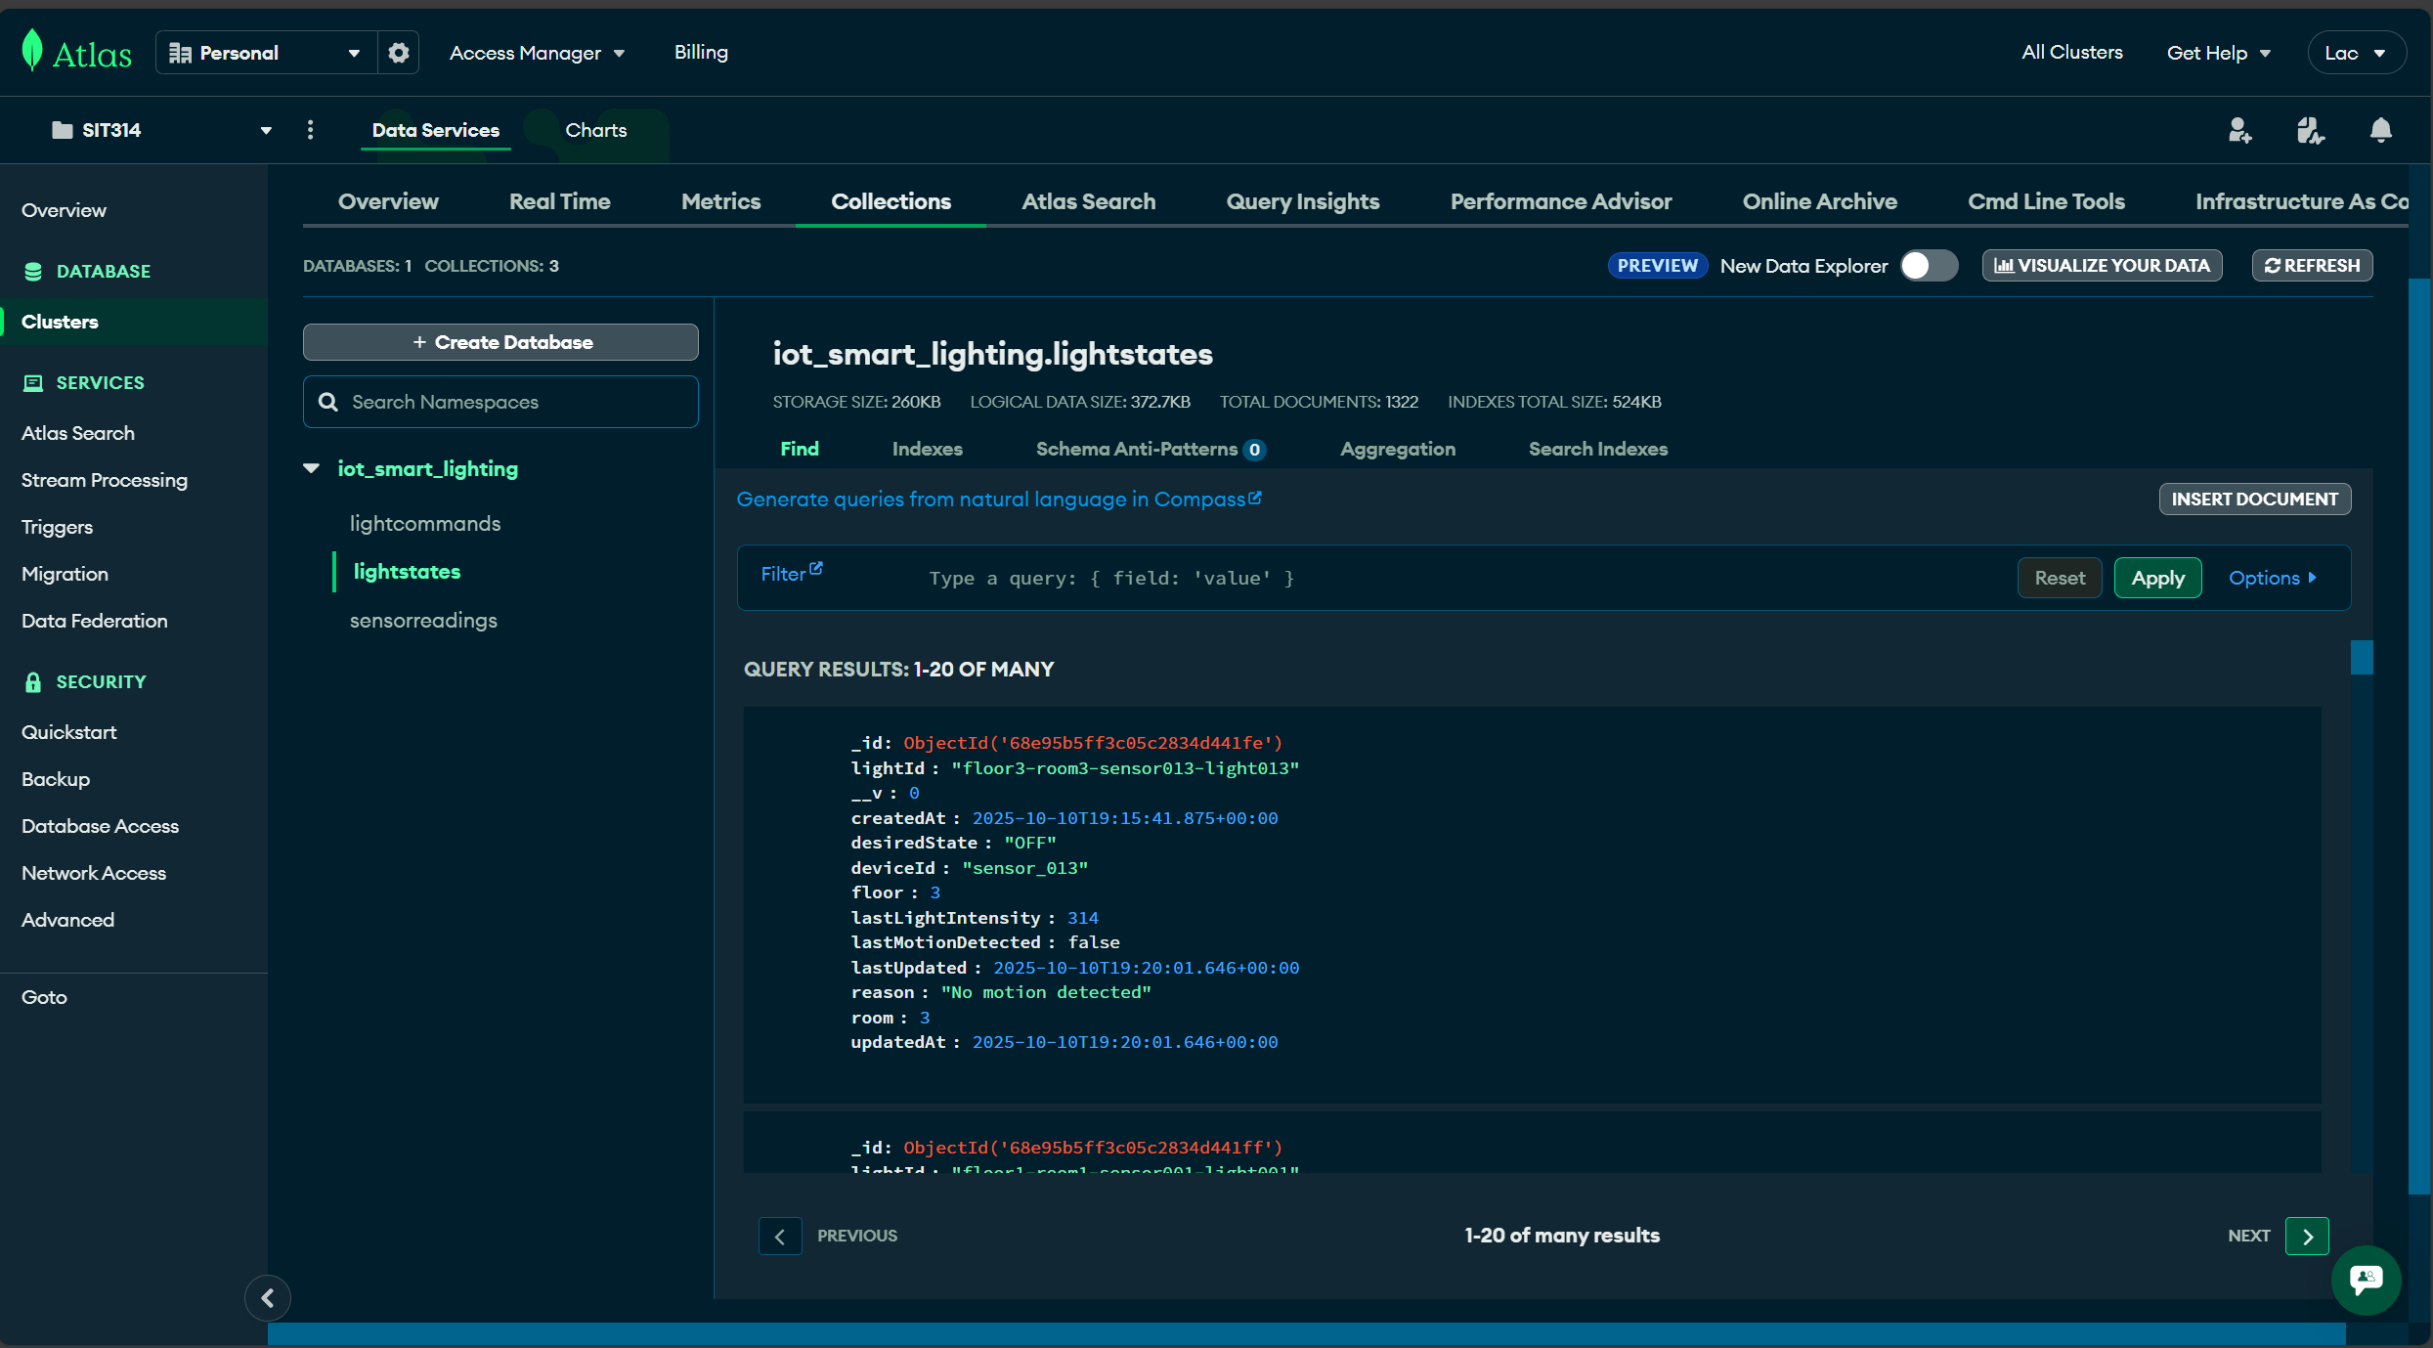
Picture 12 – “lightstates” collection are filled with processed data from automative service pods.

Metric | Value
Simulated Devices | 1,400
Test Duration | ~ 3 minutes (stopped at ETIMEOUT errors)
Sensor Reading Stored | 4,988
Light Commands Generated | 4,837
Unique Light States | 1,322
Command-to-Reading Ratio | 97.0%
Table 3 – Observed results from Kubernetes with HPA test.

Service | Initial Pods | Peak Pods | Peak CPU% | Status
Sensor Data | 1 | 15 (MAX) | 76% | Bottleneck; maxed out replicas
Automation | 2 | 4 | 94% | Scaled appropriately
Light Control | 1 | 4 | 131% | Over-threshold; scaled to handle load
API Gateway | 1 | 1 | 44% | Within limits of 60%; no scaling is needed
Table 4 – HPA Scaling behavior and explanation.
At approximately 1,400 concurrent connections, the load test script encountered `ETIMEDOUT` errors, indicating AWS IoT Core connection limits
AWS IoT Core free tier imposes connection rate limits and maximum concurrent connections (AWS IoT Core endpoints and quotas, 2025). This constraint represents a real-world bottleneck independent of the application architecture.
Observation:
- Sensor Data Service Bottleneck: Reaching maximum replicas (15 pods) at 76% CPU suggests insufficient headroom. The 10% threshold may be too aggressive for rapid scaling, or the max replicas should be increased.
- Automation Service Scaling: Scaled from 2 to 4 pods as CPU exceeded the 35% threshold, demonstrating effective HPA policy.
- Light Control Service Over-Utilization: 131% CPU indicates temporary overload before new pods became ready. This highlights Kubernetes scheduling latency.
- High Command Ratio (97%): The near 1:1 command-to-reading ratio differs significantly from Test 1 (12.1%).
- Possible explanations:
- Test stopped mid-run before state stabilization
- Higher device diversity (1,400 unique devices vs. 500) means more initial state changes
- Concurrent message processing may have introduced race conditions in state detection

C – Performance Metrics Summary
Throughput:
- Sensor Data Ingestion: ~4,988 readings / 180 seconds ≈ 27.7 readings/second
- Command Execution: ~4,837 commands / 180 seconds ≈ 26.9 commands/second
Latency:
- API Health Check (under load): ~200 - 500ms
- Automation Decision to Command: < 1 second (measured via log timestamps)
Resource Efficiency:
- Docker Compose (500 devices): 4 containers, ~300MB total memory, ~8% aggregate CPU
- Kubernetes (1,400 devices at peak): 24 pods (15+4+4+1), estimated ~6GB memory, variable CPU

VI. Discussion

A – Architectural Strengths

1. Microservices Decomposition
The separation of concerns into four distinct services provided several benefits:
- Independent Scaling: The Sensor Data Service scaled to 15 pods while the API Gateway remained at 1 pod, demonstrating granular resource allocation
- Technology Flexibility: Each service could optimize its technology stack (e.g., MQTT for event ingestion, REST for transactional operations)
- Fault Isolation: When AWS IoT Core connections failed, the Light Control and API Gateway services remained operational

2. Service – Specific HPA Tuning
- Empirically tuning CPU thresholds based on workload characteristics (10% for I/O-bound, 35% for CPU-bound) proved effective.
- However, the Sensor Data Service reaching maximum replicas (15 pods) suggests the threshold (10%) or maximum should be re-evaluated for production deployments.

3. State Change Detection
- The Automation Service's state comparison logic reduced unnecessary database writes and MQTT publishes by ~88% (Test 1: 12.1% command ratio). This pattern is essential for IoT systems where sensor readings far outnumber actionable events.

B – Identified Bottlenecks

1. AWS IoT Core Connection Limits
The inability to scale beyond ~1,400 concurrent connections represent a hard infrastructure limit. Mitigation strategies include:
- Connection Pooling: Multiple sensors share a single MQTT connection (require protocol-level changes)
- Edge Gateways: Aggregate sensor data at the edge before publishing to cloud.
- Alternative MQTT Brokers: Self-hosted Eclipse Mosquitto or EMQ X with horizontal scaling.

2. Sensor Data Service Saturation
Reach 15 pods (maximum) at only 76% CPU indicates:
- I/O Bottleneck: MongoDB Atlas free tier (M0) may throttle write operations.
- Network Latency: Cloud-hosted MongoDB introduces ~50-100ms round-trip time per write.
- Insufficient Max Replicas: Production deployments should increase `maxReplicas` to 20-30.
The possible optimization that one can take into consideration for future testing is to implement batch writes: buffer 10-50 sensor readings in memory and insert via `insertMany()` to reduce database round-trips.

3. MongoDB Atlas Free Tier Limitations
The M0 free tier imposes restrictions:
- RAM: 512MB shared memory
- Storage: 512MB
- Connections: 500 concurrent connections
With 15 Sensor Data Service pods, each creating 5 - 10 MongoDB connections, the system approaches this limit. Production deployments require paid tiers with connection pooling.

C – Comparison with State-of-the-Art Research

1. Microservices vs. Monolithic Architectures

Recent empirical and survey studies generally find that microservices improve independent scaling and resiliency under variable load, though raw performance outcomes depend on workload and service decomposition.

Comparative evaluations and reviews (e.g., MDPI Applied Sciences; Springer LNCS; Journal surveys) report that microservices often sustain higher throughput under scaling and fault isolation, while introducing coordination and networking overheads that can offset gains in certain scenarios.

This project’s observation—that independently scaling the Sensor Data Service prevented upstream pressure on the API tier—aligns with those findings on elasticity and isolation in microservices-based systems (Tapia et al, 2020; Rodrigues et al, 2024).

2. Kubernetes HPA Effectiveness
- The Kubernetes Horizontal Pod Autoscaler (HPA) is a reactive controller that adjusts replicas based on metrics sampled from the metrics API; scaling speed depends on metric freshness, polling interval, stabilization windows, and pod readiness.
- Engineering measurements place HPA reaction on the order of tens of seconds before replicas change, and overall scale-out to steady state commonly completes within ~1–2 minutes, depending on image pull and readiness. The observation of HPA actions within 1–2 minutes after threshold breaches is consistent with such reports and the reactive design described in Kubernetes documentation (Sivko, 2022).
- Moving beyond CPU, custom/event metrics—for example, MQTT message backlog or database write latency—are supported via Prometheus adapters and KEDA (which drives HPA from external triggers).
- Research and vendor guidance show that custom/event metrics can improve responsiveness for I/O-bound services compared with CPU-only policies (Lee, 2023; Guruvareddiar and Jagannathan, 2024)

3. IoT Data Management Patterns
- IoT backends typically see far more telemetry than actuation, with actuation events being comparatively sparse and bursty; the exact ratio varies widely by domain and dataset.
- Studies of smart-home/IoT streams and surveys emphasize heterogeneous rates, class imbalance, and multi-timescale data (sensors vs device/actuator events).
- The observed result of 97% command-to-reading ratio in Test 2 therefore appears atypically high relative to common datasets and warrants deeper investigation (e.g., tracing, oplog analysis, and verifying state-change detection under concurrency) (Majib et al, 2023).

4. Lessons Learned
- I/O-bound workloads → lower CPU thresholds:
  - Using a conservative CPU target is reasonable for event-driven stacks where CPU is not the primary bottleneck; HPA and request/event-driven autoscaling literature recommend choosing metrics that track true load (e.g., queue depth, request rate) (Google Cloud, n.d).

- Load tests must include managed-service limits:
  - Cloud IoT services document endpoint quotas and rates that can dominate system behavior under scale; accounting for these prevents misattributing bottlenecks (Halleb, 2025).

- State management is pivotal:
  - Event-driven designs that suppress duplicate/no-change writes reduce ingestion/storage pressure—a best practice echoed in IoT reference guidance (Hakme et al, 2022).

- Scheduler & readiness latency matter:
  - Temporary CPU overshoot before pods become Ready is a known effect of reactive HPA plus scheduling/boot time; literature on predictive/proactive autoscaling (time-series, hybrid, and learning-based approaches) shows improved pre-scale behavior versus default HPA.
  - Scheduled scaling prior to anticipated load, or predictive HPA variants, can reduce overshoot (Guruge and Priyadarshana, 2025).

VII. Future Work

A – Short-term Improvement
- Batch database writes. Introduce buffered/bulkWrite inserts to reduce round-trips and I/O overhead in the Sensor Data Service (unordered batches where acceptable) (MongoDB Bulk Write Operation, n.d.).
- MongoDB Atlas upgrade. Move to a dedicated Atlas tier (e.g., M10+) to gain isolated resources; choose tier based on connection limits and sizing guidance (MongoDB Modify a Cluster, n.d.).
- Custom HPA metrics. Drive scaling from workload signals (e.g., MQTT backlog, queue length, write latency) using KEDA or custom/external metrics rather than CPU alone (KEDA, n.d.).
- Distributed tracing. Integrate Jaeger/Zipkin to trace cross-service requests and diagnose the high command-to-reading ratio observed in Test 2 (Jaeger, n.d.).

B – Long-term Research Directions
- Edge-computing integration
  - Deploy lightweight decision logic on edge gateways to pre-filter telemetry and reduce cloud bandwidth/latency; align with recent surveys on the IoT-edge-cloud continuum and its architectural models (Gknois et al, 2023; Krekovic et al 2024).
- Machine-learning (predictive) autoscaling
  - Explore proactive autoscaling that anticipates demand (e.g., time-series or RL-based methods) rather than reacting to CPU; recent surveys and frameworks for containerized microservices report gains over purely reactive HPA (Santos et al., 2025; Nunes et al., 2024).
- Multi-cloud Kubernetes evaluation
  - Compare EKS/GKE/AKS for IoT workloads focusing on autoscaling signals (HPA+KEDA), cost, cold-start behavior, and managed ingress/observability; adopt a common test harness to ensure parity across platforms. (Background on KEDA/event metrics for portability.)
- Chaos engineering for resilience
  - Use tools such as Chaos Mesh (or service-mesh fault injection) to test failure modes—pod/node loss, latency, and partitions—and measure SLO impact; recent reviews document practices and evidence for microservices robustness (Owotogbe et al, 2024; Mahgoub, 2025).

VIII. Conclusion
This project successfully demonstrated the application of microservices architecture and Kubernetes Horizontal Pod Autoscaling to a real-world IoT smart lighting system. Load testing with 1,400 simulated devices validated the system's ability to dynamically scale from 5 to 24 pods based on workload characteristics.
Key Contributions:
- Empirical Evidence for Service-Specific Scaling Thresholds: Tuning CPU thresholds to workload types (10% for I/O-bound, 35% for CPU-bound) proved effective for IoT applications.
- State Change Detection Pattern: Implementing state comparison logic reduced database writes by 88%, demonstrating a critical optimization for event-driven IoT systems.
- Real-World Bottleneck Identification: Load testing exposed AWS IoT Core connection limits (~1,400 devices) and MongoDB Atlas free tier constraints, providing actionable insights for production deployment.
- Integration of State-of-the-Art Research: The architecture applies contemporary research on microservices, container orchestration, and IoT scalability patterns, validating these approaches in a practical context.
Alignment with Unit Learning Objectives:
- Custom Microservices: Replaced AWS Lambda with four custom Node.js/Express services
- REST APIs for MongoDB: Implemented RESTful endpoints for inter-service communication and database operations
- Horizontal Scalability: Achieved automatic scaling from 5 to 24 pods under load
- Production-Ready Design: Kubernetes manifests, health probes, and secret management demonstrate enterprise deployment readiness
Final Reflection:
- While the system successfully demonstrated core scalability principles, production deployment would require addressing identified bottlenecks (MQTT broker limits, database tier upgrades, batch processing optimizations).
- The 97% command-to-reading ratio anomaly in Test 2 highlights the importance of thorough testing under realistic load patterns. Future research should explore edge computing integration and ML-based predictive scaling to further enhance system efficiency.
- The project validates that microservices architecture, when combined with Kubernetes orchestration, provides a robust foundation for scalable IoT systems. However, careful workload characterization and service-specific tuning are essential to realize these benefits in practice.

IX. References
AWS IoT Core. AWS IoT Core endpoints and quotas. https://docs.aws.amazon.com/general/latest/gr/iot-core.html
AWS. (2025). AWS IoT Core MQTT. Retrieved from https://docs.aws.amazon.com/iot/latest/developerguide/mqtt.html
EMQX. (2022, May 9th). Reaching 100M MQTT conncetions with EMQX 5.0. Retrieved from https://www.emqx.com/en/blog/reaching-100m-mqtt-connections-with-emqx-5-0
Filippov, M., Mazzara, M. (2025). Autoscaling Containerized Microservices: A Survey. In: Barolli, L. (eds) Advanced Information Networking and Applications. AINA 2025. Lecture Notes on Data Engineering and Communications Technologies, vol 251. Springer, Cham. https://doi.org/10.1007/978-3-031-87781-0_32
Gkonis, P., Giannopoulos, A., Trakadas, P., Masip-Bruin, X., & D’Andria, F. (2023). A Survey on IoT-Edge-Cloud Continuum Systems: Status, Challenges, Use Cases, and Open Issues. Future Internet, 15(12), 383. https://doi.org/10.3390/fi15120383
Google Cloud. (n.d). Optimize Pod Autoscaling Based on Metrics. Retrieved from https://cloud.google.com/kubernetes-engine/docs/tutorials/autoscaling-metrics
Guruge, P. B., and Priyadarshana, Y. H.P. P. (2025, February 19th). Time series forecasting-based Kubernetes autoscaling using Facebook Prophet and Long Short-Term Memory. Front. Comput. Sci., Sec. Software, Vol7 – 2025. https://doi.org/10.3389/fcomp.2025.1509165
Guruvareddiar, S., Jagannathan, I., K., (2024). Autoscaling Kubernetes workloads with KEDA using Amazon Managed Service for Prometheus metrics. AWS. Retrieved from https://aws.amazon.com/blogs/mt/autoscaling-kubernetes-workloads-with-keda-using-amazon-managed-service-for-prometheus-metrics/
Hakme, A., Gupta, R., and Kalaspurkar, U., (2022, April 05th). 7 patterns for IoT data ingestion and visualization- How to decide what works best for your use case. Retrieved from https://aws.amazon.com/blogs/iot/7-patterns-for-iot-data-ingestion-and-visualization-how-to-decide-what-works-best-for-your-use-case/
Halleb, L., (2025, May 5th). A Practical Example of The Custom Metrics Autoscaler. Red Hat Developer. Retrieved from https://developers.redhat.com/articles/2025/05/05/practical-example-custom-metrics-autoscaler
Hendawi, A., Gupta, J., Liu, J. et al. Benchmarking large-scale data management for Internet of Things. J Supercomput 75, 8207–8230 (2019). https://doi.org/10.1007/s11227-019-02984-6
Influxdata. InfluxDB vs TimescaleDB – A Detail Comparison Compare influxDB and TimescaleDB for time series and OLAP workloads. Retrieved from https://www.influxdata.com/comparison/influxdb-vs-timescaledb/
Jaeger (n.d.). Architecture. Retrieved from https://www.jaegertracing.io/docs/1.23/architecture/
KEDA (n.d.). Kubernetes Event-driven Autoscaling. Retrieved from https://keda.sh/
Krekovic, D., Krivic, P., Zarko, I. P., Le, P. D., (2024). Reducing Communication Overhead in the IoT-Edge-Cloud Continuum: A Survey on Protocols and Data Reduction Strategies. Retrieved from https://arxiv.org/html/2404.19492v2
Kubernetes. (2025, October 03). Horizontal Pod Autoscaling. https://kubernetes.io/docs/tasks/run-application/horizontal-pod-autoscale/
Lee, F., (2023). Kubernetes: HorizontalPodAutoscaler evaluation based on Promestheus metric. Fabian Lee Software Engineer. Retrieved from https://fabianlee.org/2023/09/09/kubernetes-horizontalpodautoscaler-evaluation-based-on-prometheus-metric/
Mahgoub, A. (2025). From monolith to microservices: building scalable applications with Kubernetes, CI/CD, and chaos engineering. Retrieved from https://www.theseus.fi/bitstream/handle/10024/887394/Mahgoub_Ahmed.pdf
Majib, Y., Alosaimi, M., Asaturyan, A., and Perera, C., (2023, October 17). Dataset for Cyber-Physical Anomaly Detection in Smart Homes. Front. Internet Things, Sec. Security, Privacy and Authentication, Vol2 – 2023. https://doi.org/10.3389/friot.2023.1275080
Mishra, B., Mishra, B., & Kertesz, A. (2021). Stress-Testing MQTT Brokers: A Comparative Analysis of Performance Measurements. Energies, 14(18), 5817. https://doi.org/10.3390/en14185817
MongoDB (n.d.). Bulk Write Operations. Retrieved from https://www.mongodb.com/docs/v8.0/core/bulk-write-operations/
MongoDB (n.d.). Modify a Cluster. Retrieved from https://www.mongodb.com/docs/atlas/scale-cluster/
MongoDB. Best Practices for Time Series Collections. Retrieved from https://www.mongodb.com/docs/manual/core/timeseries/timeseries-best-practices/
MongoDB. Shard a Time Series Collection. Retrieved from https://www.mongodb.com/docs/manual/core/timeseries/timeseries-shard-collection/
MongoDB. Time Series. Retrieved from https://www.mongodb.com/docs/manual/core/timeseries-collections/
Nodejs. Don’t Block the Event Loop (or the Workder Pool). https://nodejs.org/en/learn/asynchronous-work/dont-block-the-event-loop
Nunes, J. P. K. S., Nejati, S., Sabetzadeh, M., and Nakagawa, E. Y., (2024, February 2nd). Self-adaptive, Requirements-driven Autoscaling of Microservices. Retrieved from https://arxiv.org/pdf/2403.08798
OASIS (2019, March 07). MQTT Version 5.0. Retrieved from https://docs.oasis-open.org/mqtt/mqtt/v5.0/mqtt-v5.0.html
Owotogbe, J., Kumara, I., Heuvel, W-J. v. d., Tamburri, D. A., (2024). Chaos Engineering: A Multi-Vocal Literature Review. Retrieved from https://arxiv.org/html/2412.01416v1
Pilyai, X., Irsyad, R.N., Zaini, I.N., Negara, R.M., Hertiana, S.N., Tulloh, R. (2024). Implementation and Benchmarking of Kubernetes Horizontal Pod Autoscaling Method to Event-Driven Messaging System. In: Barolli, L. (eds) Advances on Broad-Band and Wireless Computing, Communication and Applications. BWCCA 2023. Lecture Notes on Data Engineering and Communications Technologies, vol 186. Springer, Cham. https://doi.org/10.1007/978-3-031-46784-4_5AWS Well-Architected IoT Lens. (2024). Use an event-driven architecture in your IoT devices. https://doi.org/10.1007/978-3-031-46784-4_5
Rodrigues, H., Rito Silva, A., Avritzer, A. (2024). Performance Comparison of Monolith and Microservice Architectures. In: Tekinerdoğan, B., Spalazzese, R., Sözer, H., Bonfanti, S., Weyns, D. (eds) Software Architecture. ECSA 2023 Tracks, Workshops, and Doctoral Symposium. ECSA 2023. Lecture Notes in Computer Science, vol 14590. Springer, Cham. https://doi.org/10.1007/978-3-031-66326-0_12
Santos, J., Reppas, E., Wauters, T., Volckaert, B., and Turck, F. D., (February 2025). Gwydion: Efficient auto-scaling for complex containerized applications in Kubernetes through Reinforcement Learning. Journal of Network and Computer Applications, Vol 234 – Feb 2025, 104067. https://doi.org/10.1016/j.jnca.2024.104067
Siddiqui, H., Khendek, F., and Toeroe, M., (2023). Microservices based architectures for IoT systems – State-of-the-art review. Internet of Things, vol 23. https://doi.org/10.1016/j.iot.2023.100854
Sinha, S., (2024). State of IoT 2024: Number of connected IoT devices growing 13% to 18.8 billion globally. IOT ANALYTICS. Retrieved from https://iot-analytics.com/number-connected-iot-devices
Sivko, N., (2022). How quickly can the Kubernetes HPA scale your app?. Coroot. Retreived from https://coroot.com/blog/engineering/how-quickly-can-the-kubernetes-hpa-scale-your-app/
Tapia, F., Mora, M. Á., Fuertes, W., Aules, H., Flores, E., & Toulkeridis, T. (2020). From Monolithic Systems to Microservices: A Comparative Study of Performance. Applied Sciences, 10(17), 5797. https://doi.org/10.3390/app10175797

X. Appendix

GitHub Repository (contain of the related codes & documents):

Video Demo:

